**Spring Security**

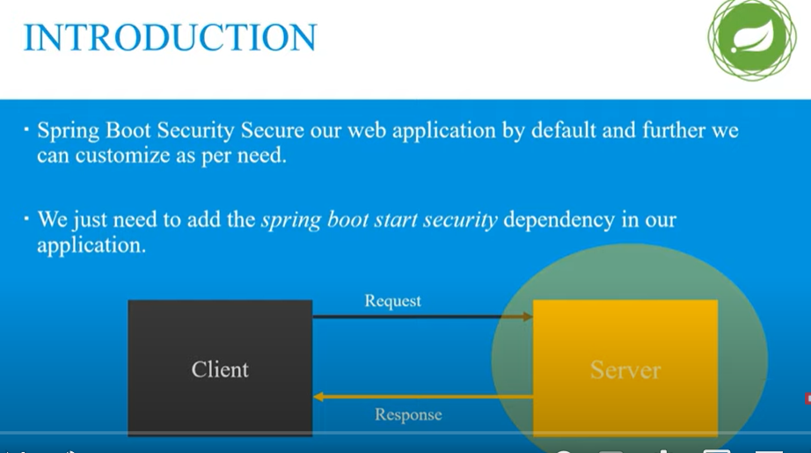

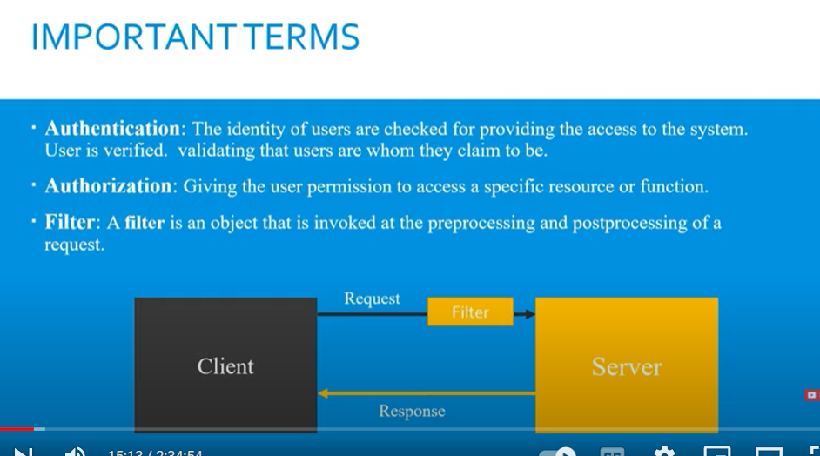

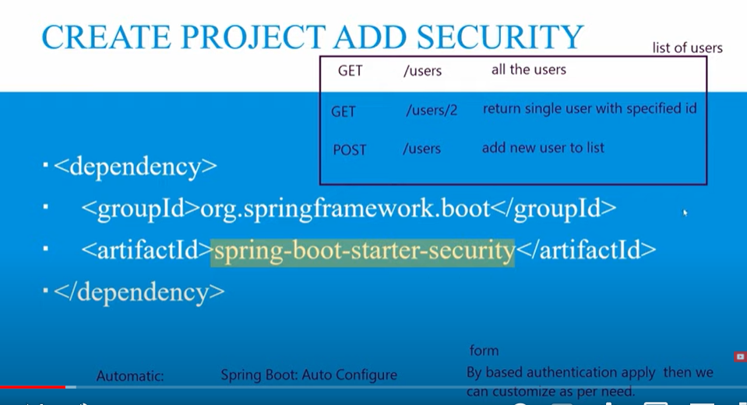

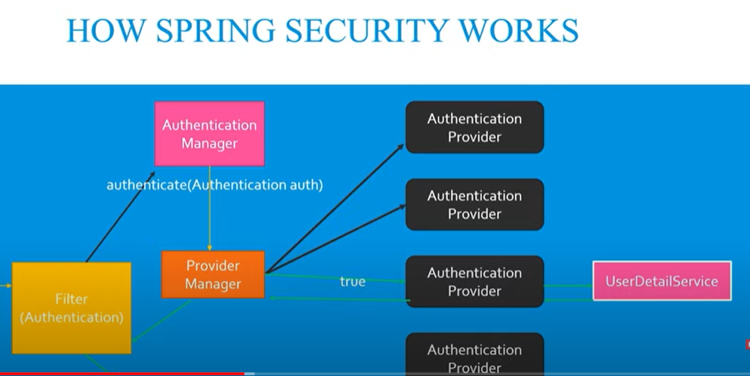

Hamare pass koe bhi request ayegi filter sab sai pehlay ayega request ko intercept karay ga filter sirf beech mai request ko pakar sakta hai filter k pass authentication ki koe power nahi hai

Filter 1 authentication ka object banayega ko us k andar basic info rakh day ga or request ko delegate karday ga authentication manager k pass

Authentication manager ka kaam hai ab wo validate karay ga k banda valid hai ya nahi

Authentication manager 1 authenticate naam ka function call karta hai or braget mai authentication pass kardeta hai

Authentication manager keh saktay hai yai 1 abstract interface hai is k pass authentication ki implementation nahi hai

Tw authentication ko call karne k liye mere pass alag alag authentication provider hai alag alag authentication provider alag alag kaam kartay hai suppose 1 token authenticate kar raha hai dosra username password authenticate kar raha hai….

Ab yai nahi pata chalay ga konsa authentication provider hamary liye sahi hai tw is k liye provider manager hota hai jo theek hota hamray liye us k against return true kardeta

Open file basicauthenticationfilter in your project

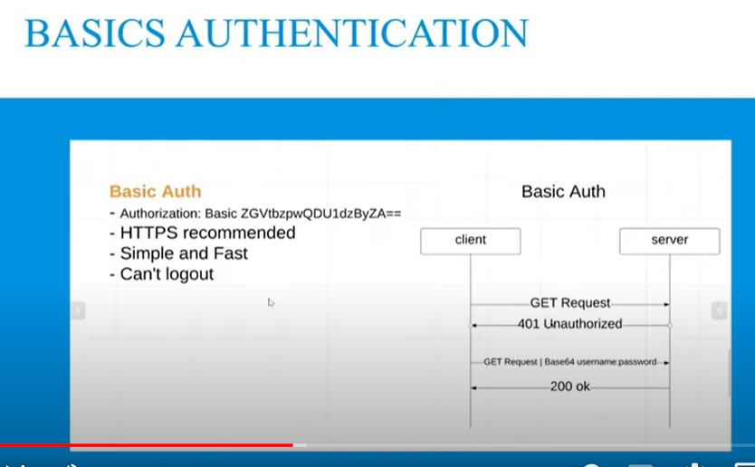

Yai recommended nahi hai q k ab JWT wagera agaye hai

Configuration karne k liye 1 new package banana hoga us k andar MySecurityConfig name sai class banayengay phr 2 annotaion humay laganai hai 1 configuration ki 2nd Enable web Security ki

Phr is class ko extend kardengay WebSecurityConfigorAdpater sai ab hamaray is mai almost sb method miljayengay but humay customize karne k liye un method ko overwrite karna hai

Alt + insert karengay to overwrite method k option ajayengay

Ab humay by default form base authentication mil rahi hai tw usko change karengay basic authentication mai



Spring security humay by default user deta hai agar humay apna user banana hai tw tw configuration karni paray gi mysecurityconfig file mai in memory or database dono use karsaktay hai



Password encoder ka jab error ayega tw tab waha no password encoder karna parta hai

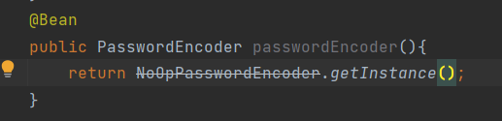

You can use this method with annotation

Bean annotation is liye use kartay hai takay hum isko kisi or jaga inject karsakay AutoWired kar sakay.

Humain database mai password encode kar k rakhna parta hai takay koe dekh na sakay tw us k liye hamaray pass BycryptPassowordEncoder hota hai

@Bean  
public PasswordEncoder passwordEncoder(){  
 return new BCryptPasswordEncoder(10);  
}

**Ant Matcher**

Ant matcher means by default kisi url ko public karsaktay means agar wo patten match karay ga tw usay public kardo

Ab for example humay multiple pages ko public karna hai tw hum

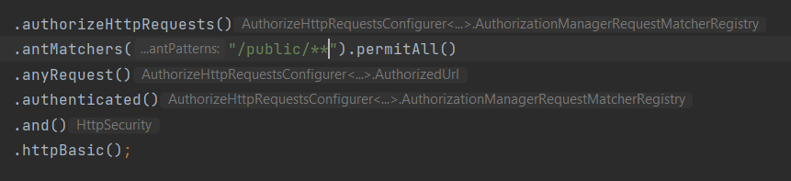

**Role Base Authentication:**

ROLE - High Level Overview->NORMAL --> READ

Authonity - permission->READ

ADMIN- READ, MRITE, UPDATE

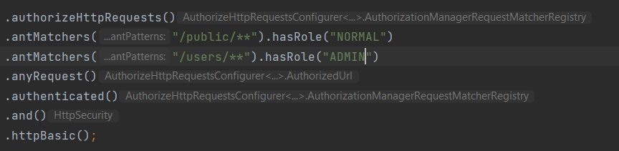

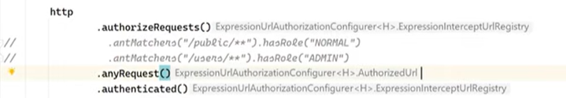

Ab yaha isko comment out kardia tw yai kaam annotation sai bhi karsaktay simple controller mai jaha url dia hoa us k uppar use karlengay

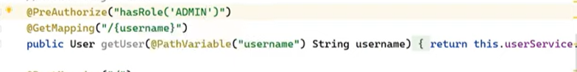

Jab bhi hum preauthorize call kartay hai tw humay configuration class mai bhi 1 annotation lagani hoti hai

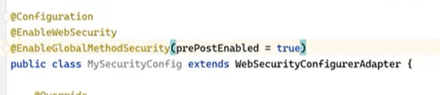

**CSRF TOKEN:**

CSRF 1 attack hai jis sai spring security humay bachata hai

Hum log jab non browser clients use kartay hai us case mai hum CSRF token ko disable kardetay hai

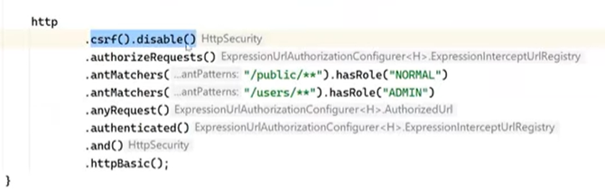

You can configure CSRF Token with the help CSRF token repository

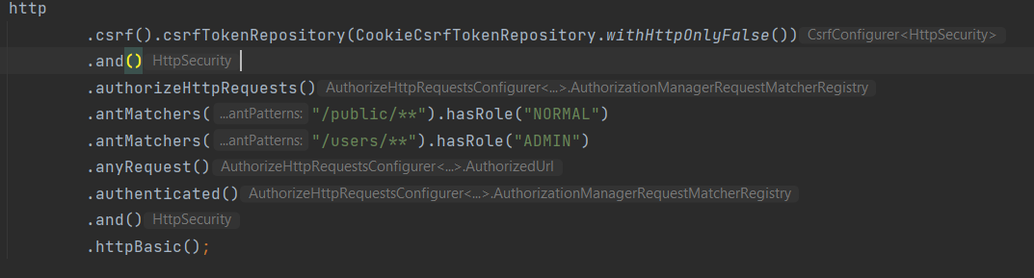

Cookie mai add hojayega csrf token

Ab agar hum postman mai cookie mai jakar dekhengay tw cookie mai araha hoga

Ab agar hum wohi cookie header mai add karday tab hi jakar user add karsaktay

X-XSRF-TOKEN yai naam add kar k agay token add kardengay

That means humnay yai prove kardia k wo user hum hi hai

**FORM BASE AUTHENTICATION:**

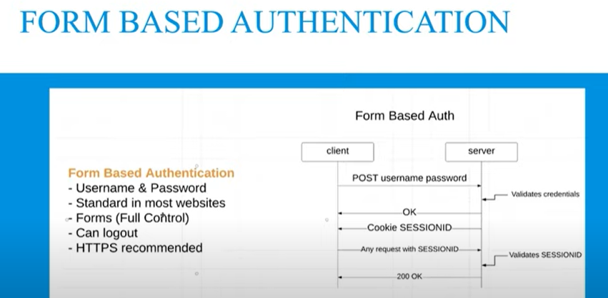

Simple http basic ki jaga form login use karlengay

Agar humay apna login page add karna hai

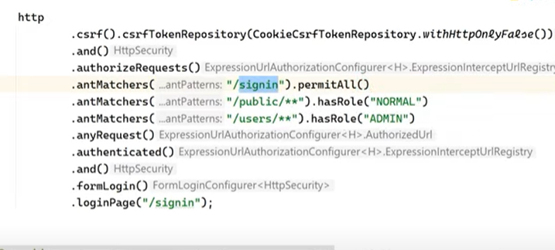

Phr controller mai end point define karna hoga

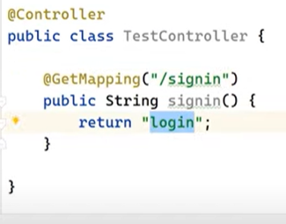

Login.html*

Us k baad resources > static > templates mai jakar page banayengay

Login page design kar k form action day dengay taky configure karsakay

